**[36] Design NFA Starts With ‘A’ And ‘B’ Which Should Accept String ABAAB**

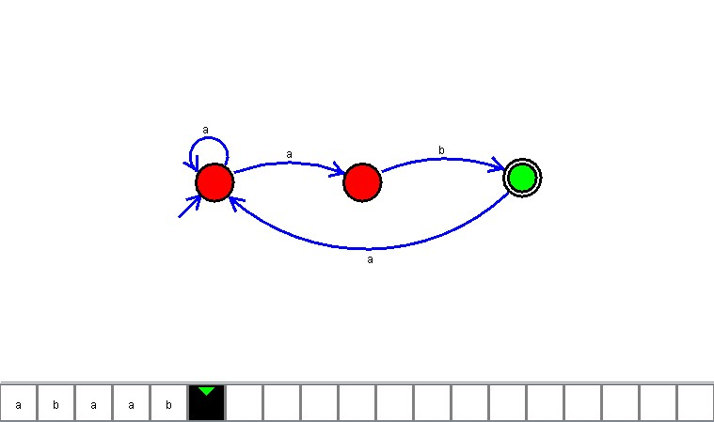

**Result**

The NFA is designed to compute the given strings as input using AutoSim tool